Project Design Phase-II
Solution Requirements (Functional & Non-functional)
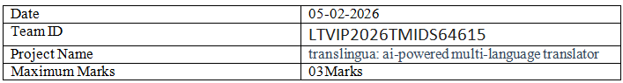
Functional Requirements:
Following are the functional requirements of the proposed solution.
Functional Requirements – Music Streaming App
FR No. | Functional Requirement (Epic) | Sub Requirement (Story / Sub-Task)
FR-1 | User Authentication | Sign up, Login, Password Reset
  OAuth login using Google / GitHub
FR-2 | Crime Posting
  Posting complaints
FR-3 |  | User will log complaints , Agent will Resolve
  Job Application & Management

Non-functional Requirements:
Following are the non-functional requirements of the proposed solution.
NFR No. | Non-Functional Requirement | Description
NFR-1 | Usability | The platform should offer a clean, intuitive UI for users of all skill levels.
NFR-2 | Security
  All data transfers must be encrypted. Implement role-based access and token auth.
NFR- | Performance | Pages should load within 2 seconds. Chat and job posting actions should be near-instant.
NFR- | Availability
  The system should maintain 99.9% uptime across all services.
NFR- | Scalability
  Should support high concurrency and rapid feature scaling through microservices.

